**UI PATH RE-FREAMEWORK**

**Why Re-Framework?**

Robotic Process Automation is never completely automated also we have to define robots is such away that they can be used in every possible situation.

* Reporting functionalities
* High extensibility
* High performance
* Recovery ability
* Reusability
* High maintainability
* Supports logging mechanism
* Ease of development

**What is Re-Framework?**

It is consist of different components.

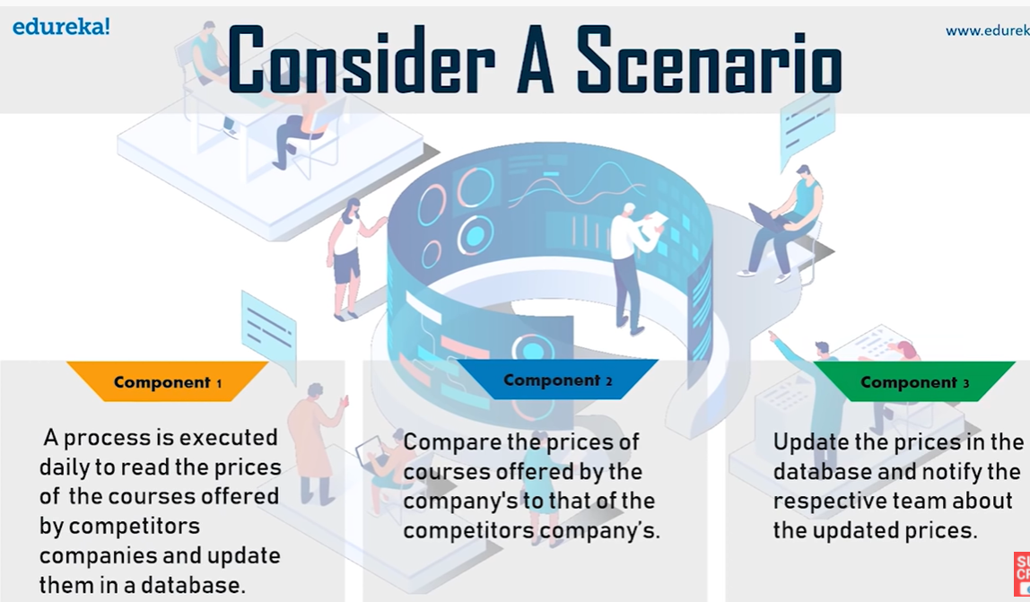

In each of the components have different transactions.

**Component-1**

* Get a list of courses
* Save the list of courses
* Check the latest prices of courses

**Component-2**

* Compare the missing factors
* Identify the differences prices

**Component-3**

* Update the prices in database
* Notify the respective team
* Generate a report

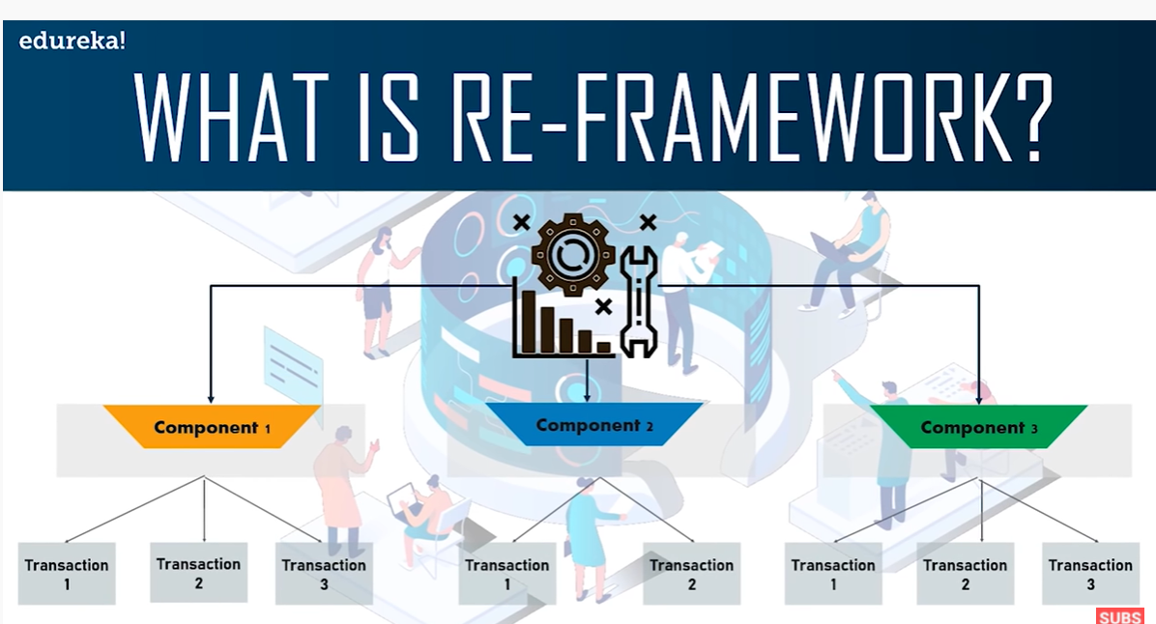

Robotic Enterprise Framework or Re-Framework is a template which is used to create automation workflow in a modular approach for large scale deployments

* Setup
* For each loop
* Perform action

**How to use Re-Framework**

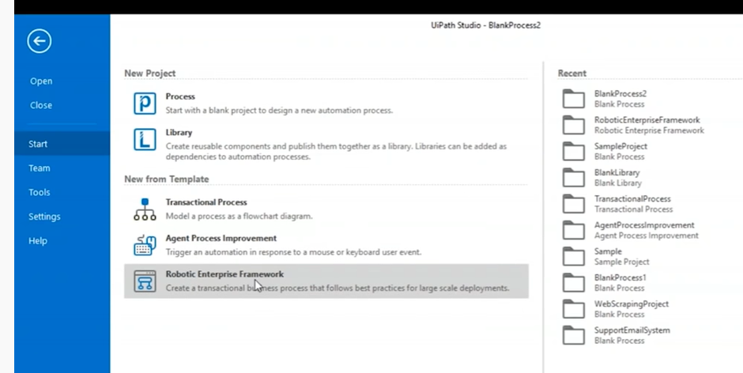

* Create a robotic enterprise framework
* Add name and description
* Going to the workflow
* Select the project tab and check all the activities are here.

**Re-framework architecture**

